Section 1 – Hero Banner
H1 + INTRODUCTION + PRIMARY CTA

AI-Powered Product Engineering Services
Accelerate digital innovation with Elevro's AI-powered product engineering services. From intelligent quality engineering and product enablement to artificial intelligence, cloud engineering and digital engineering, we help businesses develop, validate and deliver reliable, scalable digital products.
Our engineering-driven approach combines automation, continuous testing, DevOps and AI-powered intelligence to improve product quality, streamline development and enable confident releases.
Primary CTA: Explore Our Services
Secondary CTA: Talk to Our Experts
Design suggestion: Split-layout hero with content on the left and a connected AI, cloud, automation and product engineering graphic on the right.

Section 2 – Introduction / Overview
H2 + SUPPORTING DESCRIPTION

End-to-End Engineering Services for Modern Digital Products
Modern businesses need more than software development. They need intelligent engineering solutions that support quality, performance, scalability and continuous innovation throughout the product lifecycle.
At Elevro, we bring together AI-powered quality engineering, product enablement, DevOps, cloud infrastructure and digital engineering to help organisations solve complex technology challenges.
Our services support the complete product ecosystem, from embedded systems and connected devices to enterprise applications, APIs and cloud-native platforms. By integrating automation, validation and continuous delivery practices, we help engineering teams reduce risk, improve operational efficiency and accelerate product readiness.

Section 3 – Our Core Services
H2 + FIVE SERVICE CARDS WITH LINKS TO EXISTING PAGES

Explore Our AI-Powered Engineering Services
Discover engineering solutions designed to improve product quality, accelerate development and support scalable digital transformation.

1. Intelligent Quality Engineering
Improve software reliability with AI-powered quality engineering services covering test automation, functional validation, embedded testing, mobile applications, IoT systems and communication protocols. Our quality-driven approach helps identify defects earlier, strengthen test coverage and support continuous product validation.
Key capabilities: AI-Enabled Test Automation · Enterprise Web & Cloud Testing · Mobile Application Testing · IoT & Embedded Firmware Testing · Matter Testing · Protocol Validation
Explore Quality Engineering Services →

2. Product Enablement
Streamline the product development lifecycle with continuous integration, automated delivery and DevOps engineering. Elevro helps businesses build reliable CI/CD pipelines, integrate quality gates and optimise engineering workflows for efficient product development, validation and release readiness.
Key capabilities: CI/CD Pipelines · QAOps Engineering · DevOps Engineering · Infrastructure Monitoring · AIOps · Release Enablement
Explore Product Enablement Services →

3. Artificial Intelligence
Transform engineering workflows with AI-powered solutions that improve automation, testing efficiency and decision-making. From AI-based testing and generative AI for QA to release risk intelligence and AIOps, we help organisations introduce practical intelligence into their software delivery processes.
Key capabilities: AI-Based Testing · Generative AI for QA · Release Risk Intelligence · Intelligent Defect Analysis · AIOps Enablement
Explore Artificial Intelligence Services →

4. Cloud Engineering
Build and manage scalable cloud environments with Elevro's cloud engineering services. We support cloud infrastructure automation, multi-cloud management, DevOps integration and IoT cloud solutions to help businesses improve deployment efficiency, infrastructure reliability and operational visibility.
Key capabilities: CloudOps & DevOps Strategy · AWS, Azure & GCP · Multi-Cloud Management · Infrastructure as Code · IoT Cloud Solutions
Explore Cloud Engineering Services →

5. Digital Engineering
Design and engineer modern digital solutions that support business growth and evolving user expectations. Our digital engineering services focus on building scalable applications, backend systems, APIs and connected digital platforms with a strong emphasis on quality, integration and performance.
Key capabilities: Web Applications · Mobile Applications · Backend Engineering · API Integration · Digital Platform Engineering
Explore Digital Engineering Services →
Suggested layout: Five service cards in a responsive grid, each with an icon, 40–60-word description, selected capabilities and a dedicated service-page link.

Section 4 – Why Choose Elevro?
H2 + FOUR BENEFIT CARDS

Why Choose Elevro for Product Engineering Services?
Elevro combines engineering expertise, intelligent automation and continuous quality practices to help businesses build reliable digital products. Our integrated approach connects development, testing, cloud operations and AI-driven intelligence across the product lifecycle.
AI-Driven Engineering
Leverage AI-assisted testing, intelligent automation and actionable engineering insights to improve efficiency and product quality.
End-to-End Product Expertise
Connect firmware, embedded systems, applications, APIs and cloud platforms through integrated engineering and validation.
Continuous Quality & Delivery
Integrate automated testing, CI/CD pipelines and quality gates to identify risks earlier and support reliable releases.
Scalable Engineering Solutions
Build flexible automation frameworks, reliable cloud infrastructure and digital systems that support evolving business needs.

Section 5 – Our Engineering Approach
H2 + FOUR-STEP PROCESS

Our Approach to Intelligent Product Engineering
We follow a structured engineering approach that combines technical assessment, automation, continuous validation and release intelligence to support reliable product delivery.

01
Discover & Assess
Understand product requirements, system architecture, technical dependencies and engineering challenges to identify improvement opportunities.

02
Design & Engineer
Develop suitable engineering frameworks, automation strategies, infrastructure configurations and integration workflows.

03
Validate & Automate
Implement continuous testing, automated quality checks and CI/CD integration to identify defects and improve release readiness.

04
Monitor & Optimise
Use engineering metrics, operational monitoring and AI-assisted insights to support continuous improvement and system reliability.

Section 6 – Industries We Serve
H2 + SIX INDUSTRY CARDS

Industry-Focused Engineering Solutions
Elevro provides specialised engineering, automation and product validation support for industries where connected systems, software reliability and digital performance are critical.

Consumer Electronics
Testing and validation for smart devices, embedded firmware, wireless connectivity and connected consumer products.
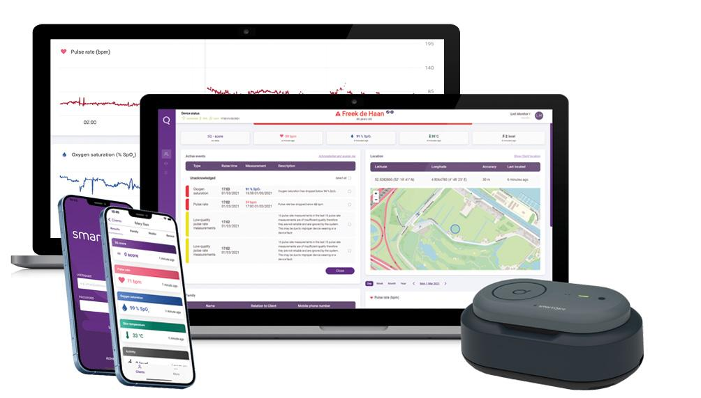
Healthcare & MedTech
Quality engineering for healthcare applications, medical technology platforms and connected health solutions.
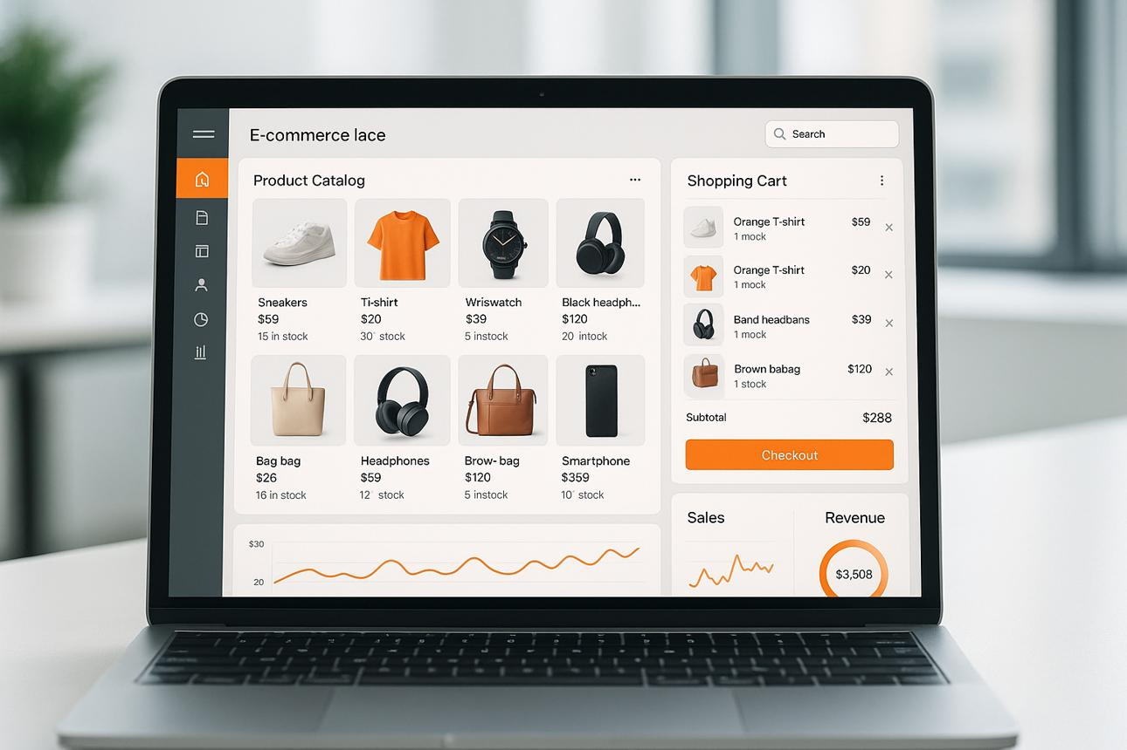
eCommerce & Retail
Validation of eCommerce platforms, customer journeys, payment workflows and backend integrations.
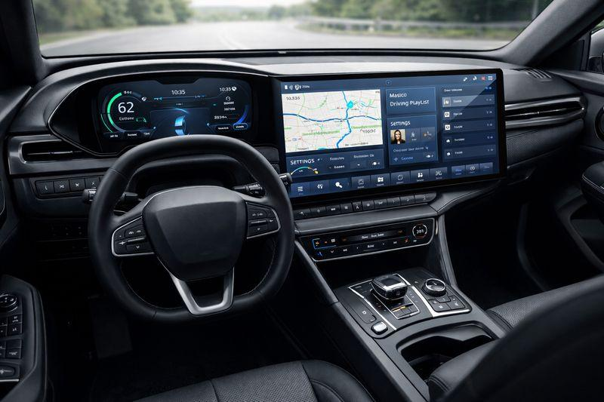
Automotive & Infotainment
Testing for in-vehicle systems, infotainment platforms, wireless connectivity and digital automotive experiences.

Smart Home, IoT & Matter
End-to-end testing for connected devices, Matter ecosystems, communication protocols and interoperability.

Cloud & SaaS Platforms
Quality engineering and automation for cloud-native applications, APIs, SaaS platforms and scalable infrastructure.

Section 7 – Business Benefits
H2 + OUTCOME-FOCUSED CONTENT

Engineering Solutions That Deliver Business Value
Our AI-powered engineering services help businesses address critical development challenges while improving quality, operational efficiency and product reliability.
- Accelerated Product Delivery: Streamline development and release processes through automated pipelines and efficient engineering workflows.
- Improved Software Quality: Strengthen validation, detect defects earlier and improve test coverage across digital products.
- Reduced Manual Effort: Apply automation and AI-assisted processes to minimise repetitive engineering and testing activities.
- Enhanced System Reliability: Improve application, device and infrastructure reliability through continuous monitoring and validation.
- Scalable Digital Infrastructure: Build cloud environments and digital platforms designed to support growth and changing requirements.

Section 8 – Insights & Ideas from the World of Engineering
H2+LATEST BLOGS & INSIGHTS
Stay informed with the latest insights on AI-powered engineering, intelligent quality assurance, cloud technologies, DevOps and digital innovation. Explore expert perspectives, industry trends and practical strategies to help businesses build smarter, scalable and reliable digital products.

Section 9 – Frequently Asked Questions
H2 + FAQ ACCORDION

Frequently Asked Questions About Our Engineering Services
1. What product engineering services does Elevro offer?
Elevro offers intelligent quality engineering, product enablement, artificial intelligence, cloud engineering and digital engineering services. These solutions support product development, testing, automation, cloud operations and continuous delivery.
2. How does AI improve product engineering?
AI helps engineering teams automate repetitive tasks, analyse testing data, identify potential risks and improve decision-making. AI-assisted quality engineering can also support test generation, defect analysis and release readiness assessments.
3. Does Elevro provide end-to-end quality engineering services?
Yes. Elevro provides quality engineering across enterprise web applications, mobile platforms, embedded firmware, IoT devices, communication protocols and cloud-connected systems.
4. What is the role of DevOps in product engineering?
DevOps connects development and operations through automated workflows, continuous integration, deployment pipelines and infrastructure monitoring. It helps engineering teams improve collaboration, delivery consistency and release reliability.
5. Which industries does Elevro support?
Elevro supports consumer electronics, healthcare and MedTech, eCommerce and retail, automotive and infotainment, smart home and IoT, and cloud and SaaS platforms.
6. How can businesses get started with Elevro's engineering services?
Businesses can contact Elevro to discuss product requirements, engineering challenges and their technology roadmap. The team can help identify relevant engineering, automation and quality solutions for their needs.

Section 10 – Final CTA

Ready to Build Smarter, More Reliable Digital Products?
Partner with Elevro to strengthen product quality, automate engineering workflows and accelerate digital innovation with AI-powered engineering services.
From intelligent testing and DevOps to cloud infrastructure and digital engineering, let's identify the right approach for your next product challenge.
Talk to Our Experts

Recommended Page Structure
Order | Section | SEO / Conversion Purpose
1 | Hero Banner | Primary keyword + CTA
2 | End-to-End Engineering Overview | Service relevance and supporting keywords
3 | Our Core Services | Service discovery + internal linking
4 | Why Choose Elevro | Differentiation and trust
5 | Our Engineering Approach | Technical expertise and process clarity
6 | Industries We Serve | Industry relevance + internal linking
7 | Business Benefits | Commercial intent and value proposition
8  9 | Blogs  FAQs | Latest Blogs & insights  Informational search intent
10 | Final CTA | Lead generation

Section 1 – Hero Banner
H1 + INTRODUCTION + CTA

Industry-Specific Product Engineering Solutions
Empowering industries with AI-driven engineering, intelligent quality assurance and scalable digital solutions.
Elevro helps businesses across diverse industries develop, test and optimise reliable digital products. From connected devices and healthcare platforms to automotive systems, eCommerce applications and cloud-native solutions, our industry-focused engineering approach combines automation, AI and technical expertise to address complex product challenges.
Primary CTA: Explore Industries
Secondary CTA: Talk to Our Experts

Section 2 – Industry Overview
H2 + DESCRIPTION

Engineering Solutions Built Around Industry Challenges
Every industry faces unique challenges in product development, system integration, software quality and digital transformation. Building reliable technology requires engineering solutions that account for industry-specific workflows, technical complexity and evolving customer expectations.
At Elevro, we combine product engineering expertise, intelligent automation, AI-powered quality engineering and cloud capabilities to help organisations address these challenges.
Our industry-focused approach supports connected devices, embedded systems, enterprise applications and cloud platforms, helping businesses strengthen product reliability, accelerate development and deliver consistent digital experiences.

Section 3 – Industries We Serve
H2 + SIX INDUSTRY CARDS

Explore Our Industry Expertise
Discover how Elevro applies specialised engineering, automation and quality assurance capabilities to support the technology needs of different industries.


1. Consumer Electronics
Deliver reliable connected experiences with quality engineering for smart devices, wearables, embedded firmware and wireless products. We support device-to-app connectivity, protocol testing, firmware validation and automated testing across complex consumer technology ecosystems.
Key capabilities: Embedded Firmware Testing · BLE & Wi-Fi Validation · Mobile App Automation · Device-to-Cloud Testing · Hardware-in-the-Loop Automation
Explore Consumer Electronics →


2. Healthcare & MedTech
Support accurate and reliable healthcare technology with specialised software testing and quality engineering. Elevro helps validate connected health devices, healthcare applications, patient-facing platforms, APIs and complex data workflows.
Key capabilities: Healthcare Application Testing · Connected Medical Device Validation · API & Database Testing · Test Automation · Regression Testing
Explore Healthcare & MedTech →


3. eCommerce & Retail
Create seamless digital commerce experiences with end-to-end quality assurance and automated testing. We help businesses validate product catalogues, pricing, inventory, checkout journeys, order management and backend workflows across eCommerce platforms.
Key capabilities: eCommerce QA · Checkout Testing · Inventory Validation · API Testing · Cross-Platform Testing · Test Automation
Explore eCommerce & Retail →


4. Automotive & Infotainment
Strengthen automotive software quality with automated validation for infotainment systems, Android Auto, Android Automotive OS and connected vehicle interfaces. Elevro supports functional testing, connectivity validation and system integration across in-car digital experiences.
Key capabilities: Android Auto Testing · AAOS Validation · Infotainment Automation · Bluetooth & Wi-Fi Testing · Vehicle Interface Validation
Explore Automotive & Infotainment →


5. Smart Home, IoT & Matter
Enable reliable connectivity and interoperability across smart home ecosystems with specialised IoT testing and automation. We validate Matter-enabled devices, wireless protocols, hubs, mobile applications, firmware and voice assistant integrations.
Key capabilities: Matter Testing · IoT Test Automation · BLE, Wi-Fi & Thread Validation · Device Provisioning · Hub Interoperability Testing
Explore Smart Home, IoT & Matter →


6. Cloud & SaaS Platforms
Support scalable cloud-native applications with intelligent quality engineering, automation and continuous delivery solutions. Elevro helps validate SaaS workflows, APIs, backend systems and cloud infrastructure to improve performance, reliability and release readiness.
Key capabilities: SaaS Application Testing · Cloud QA · API Automation · CI/CD Integration · Performance Validation · Cloud Infrastructure Automation
Explore Cloud & SaaS Platforms →

Section 4 – Industry Challenges We Solve
H2 + FOUR CHALLENGE CARDS

Solving Complex Engineering Challenges Across Industries
Modern digital products operate across interconnected applications, devices, infrastructure and data ecosystems. Elevro helps organisations address common engineering challenges while adapting solutions to industry-specific requirements.
Complex System Integration
Validate communication between devices, applications, APIs and cloud services to improve compatibility and end-to-end reliability.
Product Quality & Reliability
Strengthen software and firmware validation through structured testing, automation and continuous quality assurance.
Faster Product Releases
Reduce repetitive validation activities and streamline delivery workflows through automation, CI/CD and continuous testing.
Scalability & Performance
Support evolving infrastructure and application requirements with scalable engineering, cloud validation and performance-focused testing.

Section 5 – Our Industry-Focused Engineering Capabilities
H2 + CROSS-SERVICE CAPABILITIES

Integrated Engineering Expertise for Every Industry
Elevro connects intelligent quality engineering, AI, DevOps, cloud infrastructure and digital engineering to support the complete product lifecycle.
Engineering Capability | How It Supports Industries
Intelligent Quality Engineering | Improves application, device and system reliability through automated validation and continuous testing.
Product Enablement | Streamlines development workflows with CI/CD, QAOps, DevOps and release automation.
Artificial Intelligence | Supports smarter testing, predictive insights, engineering automation and AI-driven decision-making.
Cloud Engineering | Enables scalable cloud infrastructure, deployment automation and reliable cloud operations.
Digital Engineering | Supports development and integration across web, mobile, backend and connected product ecosystems.
CTA: Explore Our Engineering Services →

Section 6 – Why Choose Elevro?
H2 + FOUR VALUE PROPOSITIONS

Why Businesses Across Industries Choose Elevro
Elevro combines domain-specific engineering knowledge, intelligent automation and integrated quality practices to help organisations overcome technical challenges and deliver dependable digital products.
AI-Driven Engineering Expertise
Apply AI-assisted testing, intelligent automation and engineering insights to improve product quality and development efficiency.
Cross-Industry Technical Expertise
Address complex requirements across connected devices, healthcare applications, automotive systems, digital commerce and cloud platforms.
Quality-Focused Engineering
Integrate structured validation, test automation and continuous quality checks throughout product development.
Scalable Engineering Solutions
Implement flexible testing frameworks, automation pipelines and engineering practices that adapt to evolving product requirements.

Section 7 – Our Industry Engineering Approach
H2 + FOUR-STEP PROCESS

A Structured Approach to Industry-Specific Engineering
Our engineering approach aligns technical capabilities with business requirements, industry challenges and product complexity to support reliable development and continuous improvement.

01
Understand Industry Requirements
Evaluate product workflows, system dependencies, technical requirements and industry-specific risks to establish clear engineering priorities.

02
Design Engineering Solutions
Develop tailored validation strategies, automation frameworks, integration workflows and infrastructure approaches aligned with product objectives.

03
Implement & Validate
Execute automated testing, system validation, integration checks and continuous quality processes across connected product environments.

04
Optimise & Scale
Monitor engineering outcomes, improve automation coverage and refine delivery workflows to support product evolution and reliable releases.

Section 8 – Case Studies
H2 + THREE CASE STUDY CARDS

Real-World Engineering Applications Across Industries
Explore how specialised engineering, automation and quality assurance approaches address product challenges across connected devices, automotive platforms and IoT ecosystems.
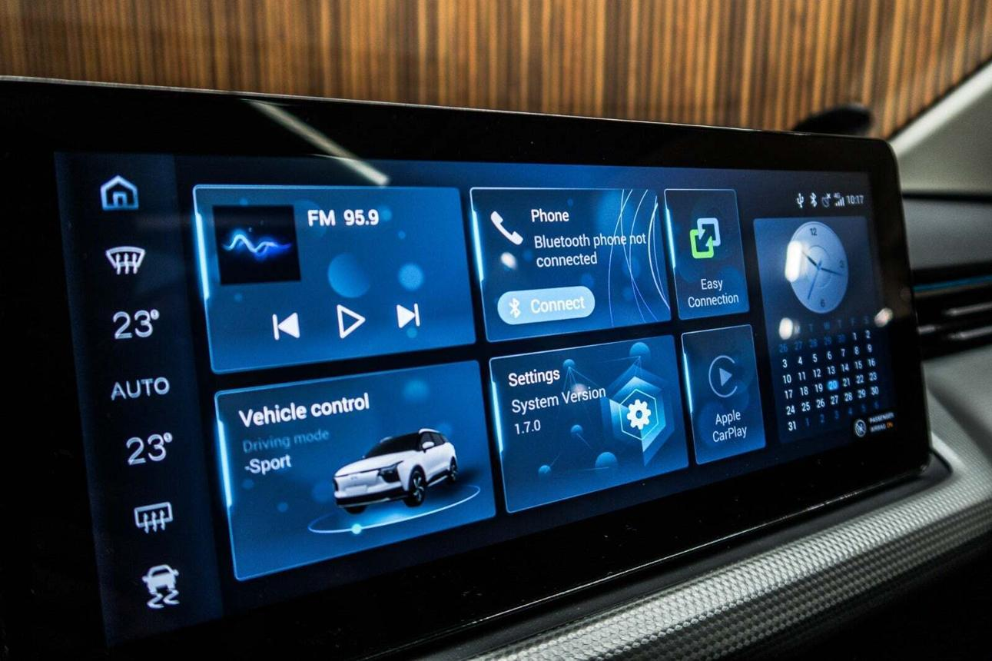
AUTOMOTIVE & INFOTAINMENT
Android Auto Test Automation
Automated connectivity, user interface, media playback and call workflow validation to support reliable in-vehicle experiences.
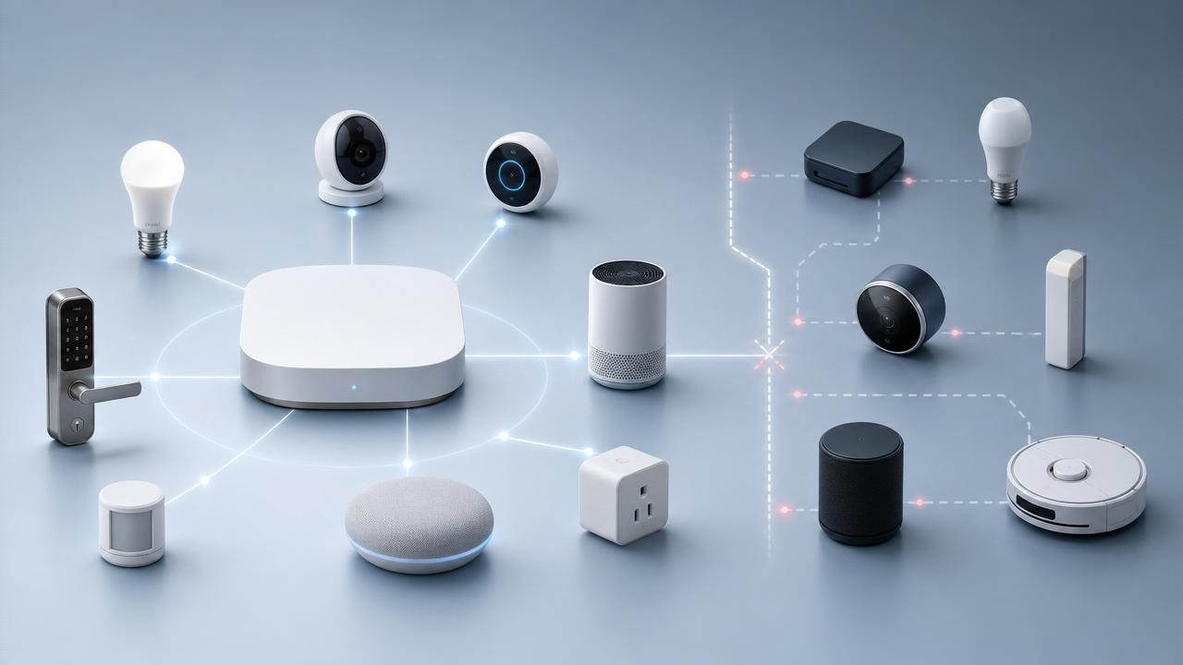
SMART HOME & IOT
Matter IoT Test Automation Framework
Automation for device provisioning, mobile interactions, voice commands and interoperability testing across connected ecosystems.
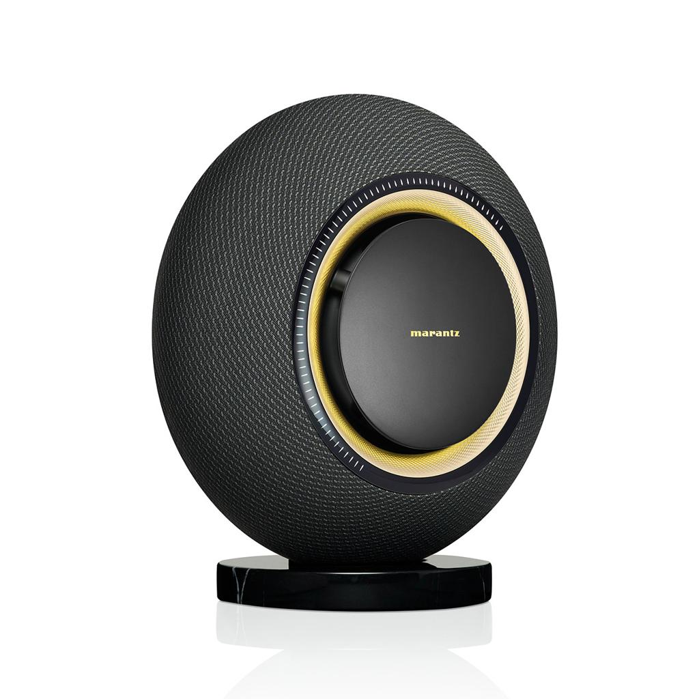
CONSUMER ELECTRONICS
Smart Audio Device Test Automation
Automated validation across Bluetooth, Wi-Fi, audio interfaces, voice integrations and firmware workflows.
Section CTA: Explore All Case Studies →
Case study topics are based on Elevro's published engineering portfolio.
Elevro
+1

Section 9 – Benefits
H2 + BENEFITS GRID

Driving Better Engineering Outcomes Across Industries
Elevro helps organisations improve engineering processes, strengthen product reliability and deliver technology solutions aligned with industry-specific business goals.
- Improved Product Quality: Identify potential defects earlier through structured validation, automation and continuous testing.
- Faster Time to Market: Streamline engineering workflows and reduce repetitive processes through CI/CD and test automation.
- Enhanced System Reliability: Support consistent performance across applications, firmware, connected devices and cloud environments.
- Reduced Engineering Complexity: Simplify interconnected technology workflows through integrated engineering and quality assurance practices.
- Greater Automation Efficiency: Reduce manual testing dependencies and support repeatable validation across product releases.
- Scalable Product Development: Build engineering foundations that adapt to evolving technical, operational and business requirements.

Section 10 – Industry Insights & Blogs
H2 + BLOG CARDS

Industry Insights & Latest Innovations
Stay ahead of industry trends with expert insights on AI-powered engineering, intelligent quality assurance and digital transformation. Explore emerging technologies, industry-specific challenges and practical strategies that help businesses improve product quality, accelerate innovation and build reliable digital solutions.
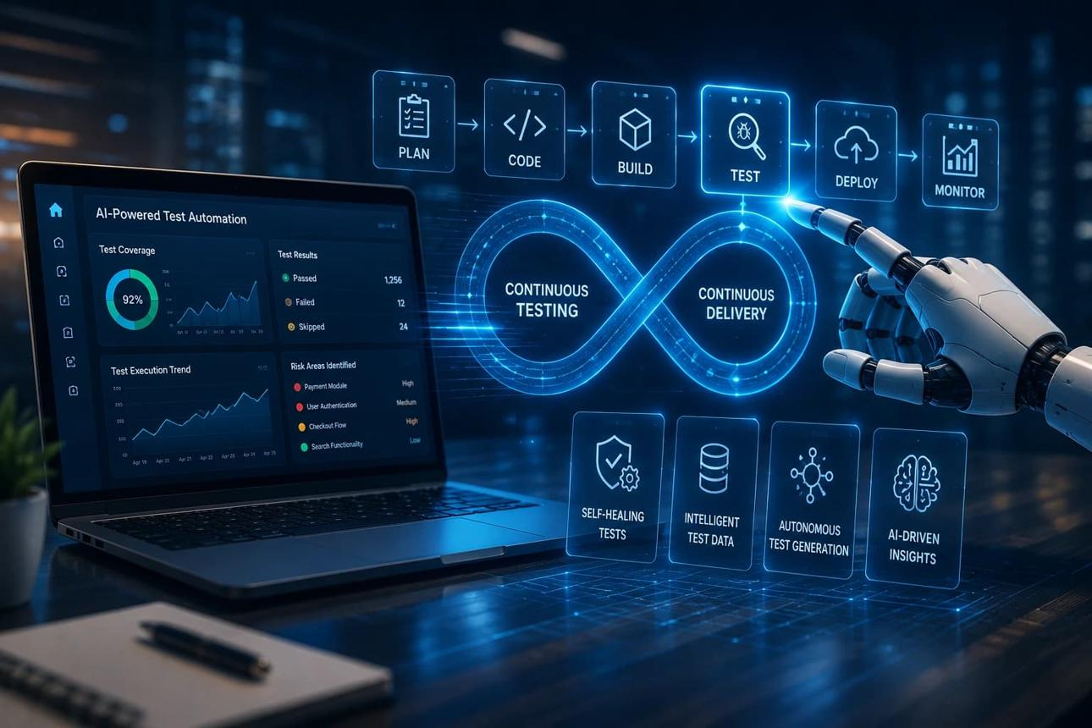
AI & QUALITY ENGINEERING
AI-Based Testing for Modern Product Teams
Explore how AI-assisted testing and quality intelligence can support modern software and product teams.
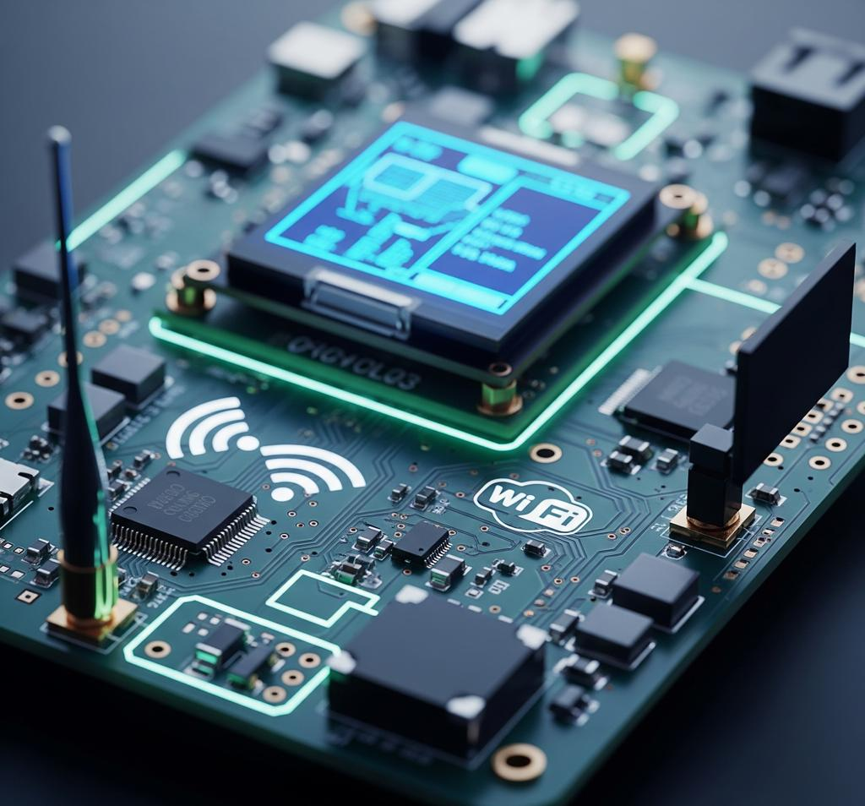
CONNECTED DEVICES
Protocol Automation for Connected Devices
Understand testing approaches for BLE, Wi-Fi and communication protocols across connected product ecosystems.

EMBEDDED SYSTEMS & DEVOPS
Building CI/CD Quality Gates for Embedded SDKs
Learn how automated regression, code quality checks and CI/CD workflows support firmware release readiness.
Section CTA: Explore All Insights →

Section 11 – Frequently Asked Questions
H2 + SIX FAQS

Frequently Asked Questions About Our Industry Solutions
1. Which industries does Elevro serve?
Elevro provides engineering and quality assurance solutions for consumer electronics, healthcare and MedTech, eCommerce and retail, automotive and infotainment, smart home and IoT, and cloud and SaaS platforms.
2. How does Elevro address industry-specific engineering challenges?
Elevro evaluates each industry's technical requirements, product workflows and system dependencies before developing appropriate engineering, testing and automation approaches.
3. Does Elevro provide software testing services across different industries?
Yes. Elevro offers intelligent quality engineering and automated testing for enterprise applications, mobile platforms, embedded firmware, connected devices, APIs and cloud systems.
4. How does AI-powered engineering benefit different industries?
AI-powered engineering can help reduce repetitive testing activities, analyse quality data, identify potential defects and support faster, more informed product release decisions.
5. Can Elevro support IoT and connected device engineering?
Yes. Elevro supports embedded firmware validation, wireless connectivity testing, Matter-enabled devices, mobile application integration and interoperability testing across connected ecosystems.
6. How can businesses get started with Elevro's industry solutions?
Businesses can contact Elevro to discuss their industry requirements, product challenges and engineering objectives. The team can assess relevant quality engineering, automation, AI, cloud and digital engineering capabilities for the project.

Section 12 – Final CTA

Let's Solve Your Industry's Engineering Challenges
Every industry has unique technology demands. Elevro brings together domain-focused engineering expertise, AI-powered automation and continuous quality practices to help you build reliable, scalable and high-performing digital products.
Connect with our experts to explore engineering solutions tailored to your industry and product requirements.
Talk to Our Experts

Complete Page Structure
No. | Section
1 | Hero Banner
2 | Industry Overview
3 | Industries We Serve
4 | Industry Challenges We Solve
5 | Industry-Focused Engineering Capabilities
6 | Why Choose Elevro
7 | Our Industry Engineering Approach
8 | Case Studies
9 | Business Benefits
10 | Industry Insights & Blogs
11 | FAQ
12 | Final CTA

